**Booting build and deployment Infrastructure as code**

**Background:**

A developer team has worked on some open source project (sagan) which is in java and the framework used is Spring boot.   
Project Link: <https://github.com/spring-io/sagan>

**Problem Statement:**

As a Cloud Engineer, you need to create the infrastructure followed by CI/CD. Here is the Architecture overview, it's not necessary you need to follow this and we welcome any new solution:

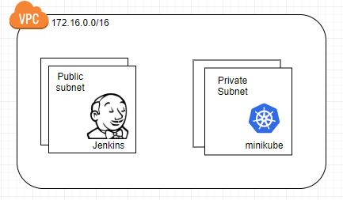

**Task :** Using any IaC create the same infra which is depicted above. In this, you also need to use the userdata to install Jenkins and Minikube.

**Note:** You need to create a one-click solution for the above task